**Custom Requirements Document**

**Gate**: B1

**Region**: AP

**Segment**: BM

**Account Manager**: Leon Li

**Product Manager:** John Xiong

**Customer**: SUNDIRO (HONDA MOTORCYCLE)

**Opportunity Description:**

We have been selling FBT-50/PBT-50 for many years in AP. Recently, customers come to ask for new motorcycle tester that have batter user interface as well as data storage or transfer capability. We plan to immigrate PBT-50 algorithm onto CBT-300 to develop a low cost motorcycle battery tester for reinvention and further penetration.

Honda Motorcycle has more than 3500 dealers in China. After an initial contact, they show very strong interest in such a tester at $120/unit. We have big chance to cover all its dealers with a direct sales.

We will provide a demo version CBT-350 and demo APP for Honda validation in Sep. This CRD is to define a rough requirements for the demo only. For more specific requirments for the final product, we will run the gates later after the trial.

**Customer Business Goal(s):**

* An enhanced and efficient tool to for battery promotion and warranty management

**Midtronics Business Goals:**

* Business growth (opportunity of 1 million sales)
* Platform reinvention and penetration

**Custom PN:**

* CBT-350 HM

**What is custom:**

* Hardware:

PCBA – same as CBT-300 JCI

Housing – same as CBT-200 Royal Green/AC DELCO (Black plastic, red button, English

* Software: Change screen flow based on CBT-300 JCI; Take the algorithm of PBT-50 IN AP

**Initial screen**



**BT MODE**

CBT-350 is by default in BT mode when it powers on. In this mode, android devices initiate BT connecton, and send REF# to CBT-350, and receive test result. The whole processes are exactly same as what the demo version APP does, except that REF# is required to input on the APP instead of battery type and CCA.

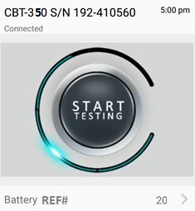

**None BT MODE:**

On initial screen, if pressing “ENTER”, tester enters none BT mode. Users can input REF#, and press enter to start test.



Test result shows Decision, Voltage, Measured CCA and Battery Ref#.

